**Why MSIS @SCU?**

**Below are the listed metrics developed on the MSIS program offered at Santa Clara University, ranked in the order of their suitability.**

**Metrics 1: Average Salaries earned by the Alumni**

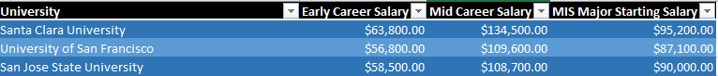

According to 21st College Salary Report, students graduated from Santa Clara University are paid higher starting and mid-career Salaries in comparison to University of San Francisco and San Jose State University.

Also, for the Major MIS, SCU Alumni is earning more, which clearly shows why MSIS program at SCU is better in terms of salary. One important reason behind this could be the curriculum designed for the students. At SCU, coursework is project-based, connecting learning to actual challenges in the field. The other important reason would be the location. SCU is ideally positioned at the heart of the valley, which gives MSIS students exposure to leading edge technology and potential employers.

**Metrics 2: GPA Breakdown**

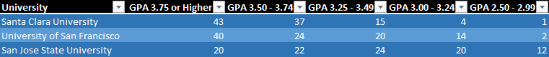

In choosing a university to attend, it is important to find a good fit – a place that provides a challenging academic environment. The table provides us the information about what is the percentage of students that fall under a particular GPA Range. We can clearly see that 43% of students at SCU have GPA 3.75 or Higher, while at SJSU and University of San Francisco this percentage is 20% and 40% respectively.

The GPA Breakdown statistics shows that at SCU, there is a competitive environment which motivates students to perform well and shine!

**Metrics 3: Graduation Rate**

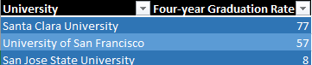

The statistics compare students graduating from three universities and clearly, students at SCU graduate more. Graduation Rate tells about the time in which a student enters and completes a degree. So, for SCU, 77%(out of 100%) enrolled students complete their degrees in 4 years. While this percentage is very low for San Jose State University.

This Graduation Rate acts as a measure for accountability and transparency. Low GR can imply that students are not getting the academic support they need to succeed, that they are disappointed by the faculty or staff, or that they find life at the school unaffordable.

And that may give pause to a prospective student. Extended enrollment is costly, so the best course is to finish on time.

**Metrics 4: Student – Faculty Ratio**

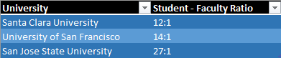

In general, the lower the student to faculty ratio, the better. After all, a low ratio should mean that classes are small and faculty members can spend more time working individually with students. SCU has the lowest Student to Faculty ratio as compared to SJSU and University of San Francisco.

If a college has more than 20 to 1 student to faculty ratio, that's an immediate red flag. That's an unhealthy number that almost guarantees that instructors will not be overly invested in mentoring all of their students closely, which is the case for San Jose State University.

**Metrics 5: Crime Statistics**

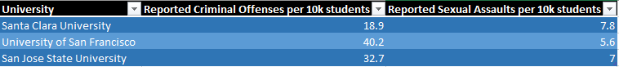

(50 Reported Offenses per 10k students)

To thoroughly evaluate a school's safety, prospective students need to research crime statistics about the school. This may help people become informed about the crime in their city. As, we can see for Santa Clara University it is as low as 18.9 for reported criminal offenses and 7.8 for Sexual assaults. The reason might be the area where the college is located. In comparison to SJSU (San Jose) and University of San Francisco (San Francisco), SCU (Santa Clara) is considered a safer place to stay.

After taking into view all the five metrics, the three most important ones are:

* **Average Salaries earned by the Alumni**
* **GPA Breakdown**
* **Graduation Rate**

**Audience:** The Prospective students

**Need of the Audience**: Audience need to decide about the best fit college keeping in mind all the key metrics provided.

**What does Audience want**: The information we are trying to provide, must really come out of the visualization at one go. The Viz must be visually impressive and direct in displaying information.

**Fears of the Audience:** While viewing my visualization, the prospective students might think that what if these statistics are not from a reliable source. What if websites of other colleges are showing good metrics for their stats.

**Substitutes:** Recommendations from Alumni or Faculty. Searching websites of many colleges and taking help of counsellors.

Here is the link to the Tableau Visualization of top three metrics:

<https://public.tableau.com/profile/tanushree3514#!/vizhome/WhyMSISatSCU/WHYSCU?publish=yes>

Link to google slide on top three metrics:

<https://docs.google.com/a/scu.edu/presentation/d/1Olu510WOpzErWFK2VBcI0pE9NaYmkJoRZRk8r80GLDY/edit?usp=sharing>